**Sample Test – InClass1** (Closed Book)

**Time: 01 Hour**

**Instructions:**

This test consists of 20 Multiple Choice Questions to be answered in 60 minutes. There are 5 answer choices, but only one choice is correct. You need to pick the correct one. A general advice is, you should not spend more than 3 minutes on any one question. Rough work may be done on separate sheets.

1. The formula A: **p→(p→q)** is:

1. (a) Satisfiable

(b) unsatisfiable

(c) valid

(d) an axiom

(e) none of the above

2. Let p = ‘Sam is studying Math’; and q = ‘Pat is studying English’.

The proposition “either Sam is studying Math and Pat is not studying English, or Pat is studying English” can be correctly expressed in symbolic form as:

1. (a) (p ˅ q) ˄ ¬ q
2. (b) (p ˄ ¬ q) ˄ q
3. (c) (c) (¬ p ˄ q) ˄ q

(d) (p ˄ ¬ q) ˅ q

(e) none of the above

3. Consider the two propositions,

p: ‘x is an even integer’; and q: ‘x is divisible by 4’.

Which of the following formulae is unsatisfiable?

1. (a) (p ˄ q) ˄ ¬ q
2. (b) (p ˅ q) ˅q
3. (c) (p ˄ q) ˄ q
4. (d) (p ˅ q) ˄ ¬ q

(e) none of the above

4. If the expression ((p → q) ˄ ¬ p) → ¬ q is False, then

1. (a) ((p → q) ˄ ¬ p) is True, and p is False
2. (b) p is True
3. (c) q is False

(d) p → q is False

(e) none of the above is correct

5. Consider the two propositions,

p: ‘Tony is playing cricket; and q: ‘Tony is playing tennis’.

The correct symbolic form for the logical consequence “Tony is playing cricket or Tony is not playing tennis. If Tony is playing tennis then Tony is not playing cricket. Therefore, Tony is playing cricket” is:

1. (a) (( p ˅ ¬ q) ˄ (q → ¬ p)) → p
2. (b) (( p ˅ ¬ q) ˅ (q → ¬ p)) → p

(c ) (( p ˄ ¬ q) ˄ (q → ¬ p)) → p

(d) (( p ˅ q) ˄ (q → p)) → q

(e) none of the above

6. Suppose

A = {a, 2*a, 3*a}; B = {b, a*b, a+b} are two sets with a = 2 and b = 3.

Then, A U B and A ∩ B are respectively:

1. (a) {2, 3, 4, 6}, {6}
2. (b) {2, 3, 4, 5, 6}, {6}
3. (c) {2, 3, 4, 5}, { }
4. (d) {2, 3, 5, 6}, { }
5. (e) {2, 3, 4, 5, 6, 6}, {6, 6}

7. Let A = {x ε ℕ | x < 5}; B = {y ε ℕ | 3 ≤ y < 6}, and the universal set,

**U** = { x ε ℕ | x < 7} where ℕ is the set of natural numbers starting with 1.

Then, (A U B)c is:

1. (a) { }
2. (b) {5, 6}
3. (c) {6}
4. (d) {5}
5. (e) {4}

8. Let A = {{1}, {1,2}}. Then, the powerset of A and its cardinality are respectively:

1. (a) { { }, {1}, {1, 2}, { {1}, {1,2}} }, 5
2. (b) { { }, {{1}}, {{1,2}}, A}, 4
3. (c) { { }, {{1}}, { {1}, {2}}, A}, 5
4. (d) {{ }, {1}, {{1}, {2}}, {A}}, 5
5. (e) none of the above

9. Let A = {x ε ℝ | 2 ≤ x ≤ 9}. Then, the new interval, B given by

B = {x εA | x2 ε A}is:

1. (a) B = [2, 3)
2. (b) B = (2, 3]
3. (c) B = [2, 3]
4. (d) B= (2, 3)
5. (e) B = [2, 9]

10. Let ℕ be the set of natural numbers starting with 1.

The set A = {(x, y): x ε ℕ, y ε ℕ, 1 < x ≤ y < 4} can be alternatively written as:

1. (a) A = {(2,3)}
2. (b) A = {(2,2), (3,3) }
3. (c) A = {(2,2), (3,3), (2,3)}
4. (d) A = {(1,1), (2,2), (3,3), (1,2), 2,3)}
5. (e) none of the above

11. Let ℕ be the set of natural numbers starting with 1.

Consider the two sets, A = {(x,y) | x ε ℕ, y ε ℕ, 2 < x = y <5}and

B = {{(x,y) | x ε ℕ, y ε ℕ, 2 < x < y <5}. Which of the following is true?

1. (a) A ⸦ B
2. (b) B ⸦ A
3. (c) A ∩ B = {(3,3)}

(d) A U B = {(3,3), (4,4), (3,4)}

(e) A U B = {(3,3), (4,4)}

12. Consider the set A = {0, 1}. Then, the set R = {(x,y) | x, y ε A; x + y = 0} describes,

(a) Only a symmetric relation on A

(b) Only a transitive relation on A

(c) Only a reflexive relation on A

(d) An equivalence relation on A

(e) None of the above

13. Let A = {a, b} and B = {1, 2}. Which of the following is a function with domain A and co-domain B?

(a) {(a, 1), (a, 2), (b, 1), (b, 2)}

(b) {(a, 1), (b, 1)}

(c) {(a, 2), (b,1), (b, 2)}

(d) {(a, 1)}

(e) {(b, 2)}

14. Let A = {a, b, c} and B = {0, 1}. Which of the following is a function with domain A and co-domain B?

(a) {(a, 0), (c, 0)}

(b) {(a, 1), (b, 0), (b, 1)}

(c) {(a, 0), (a,1), (b, 0), (c, 1)}

(d) {(a, 0), (b, 0), (c, 1)}

(e) {(a, 0), (b, 1)}

15. Let A = {a, b, c} and B = {0, 1}. Which of the following is a function with domain B and co-domain A?

1. (a) {(0, a), (1, b)
2. (b) {(0, a), (0, b), (1, c)}
3. (c) {(a, 0), (b, 1), (c, 0)}
4. (d) {(a, 1), (b, 1), (c, 0)}
5. (e) {0, a), (0, b)}

16. For the following graph, which of the following is correct?

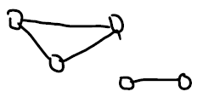

(a) Disconnected and acyclic

(b) Connected and acyclic

(c) Disconnected and cyclic

(d) Connected and cyclic

(e) None of the above

17. Consider a set of nodes, V = {(1) bread, (2) chicken rice, (3) chicken kottu}. Suppose the prices are given as: (1) Rs 250 (2) Rs 250 (3) Rs 300.

Let E = {(x, y) | x ε V, y ε V, ‘x is cheaper or same price as y’}. Which of the following directed graphs is correct?

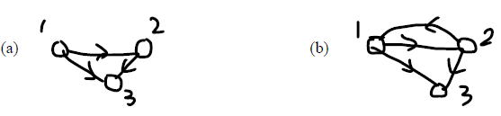

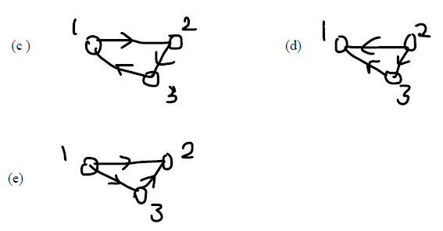

18. For the graph (V, E) where V = {a, b, c, d} and E = {(a,b), (b,c), (c,a), (a,d), (c,d)}. Which of the following is a directed and cyclic graph?

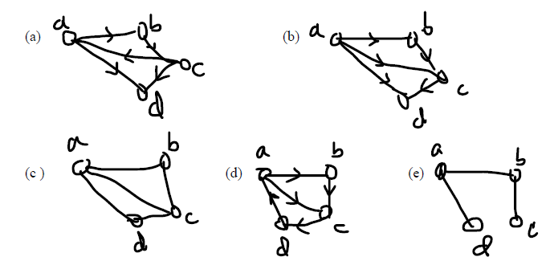

19. Consider the following graph and find the correct description about it:

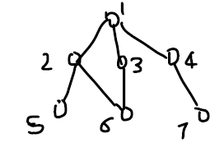

20. Find the correct description about the following tree:

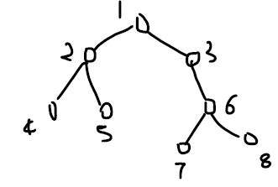

1. (a) A binary tree with depth = 3
2. (b) A non-binary tree with depth = 3
3. (c) A binary tree with left sub-tree {(1,2), (2,4)}
4. (d) A non-binary tree with depth = 4
5. (e) None of the above.

Answers:

1. (a) 2. (d) 3. (a) 4.(a) 5. (a)

6. (b) 7. (c) 8. (b) 9.(c) 10. (c)

11. (d) 12. (d) 13. (b) 14. (d) 15. (a) 16. (c)

17. (b) 18. (a)

19. (c) 20. (a).